Homework
Resolution predicate
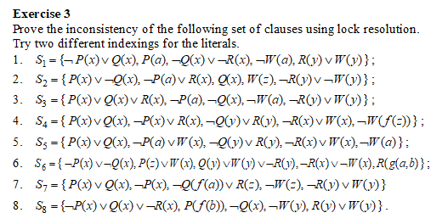

Indexing I.
- C₁ = ₍₁₎P(x) v ₍₂₎Q(x)
- C₂ = ₍₃₎¬P(x)
- C₃ = ₍₄₎¬Q(f(a)) v ₍₅₎R(z)
- C₄ = ₍₆₎¬W(z)
- C₅ = ₍₇₎¬R(y) v ₍₈₎W(y)

C₆ = Res^{pr}(C₁, C₂) = ₍₂₎Q(x)
C₇ = Res^{pr}_{theta = [x←f(a)]}(C6, C3) = ₍₅₎R(z)
C₈ = Res^{pr}_{theta = [y←z]}(C7, C5) = ₍₈₎W(z)
C₉ = Res^{pr} = (C4, C8) = □

Indexing II.
- C₁ = ₍₂₎P(x) v ₍₁₎Q(x)
- C₂ = ₍₃₎¬P(x)
- C₃ = ₍₅₎¬Q(f(a)) v ₍₄₎R(z)
- C₄ = ₍₆₎¬W(z)
- C₅ = ₍₈₎¬R(y) v ₍₇₎W(y)

C6 = C4, C5 [y ← z] → ₍₈₎¬R(z)
C7 = C3, C6 → ₍₅₎¬Q(f(a))
C8 = C7, C1 [x ← f(a)] → P(f(a))
C9 = C8, C2 [x ← f(a)] → □

